Design Note: Idempotent Transaction Processing Service

1. Architecture
The service ingests transactions that may arrive duplicated, out of order, or malformed, and applies CREDIT and DEBIT operations to account balances exactly once. It is built as ports and adapters so the input source can be replaced without touching business logic.
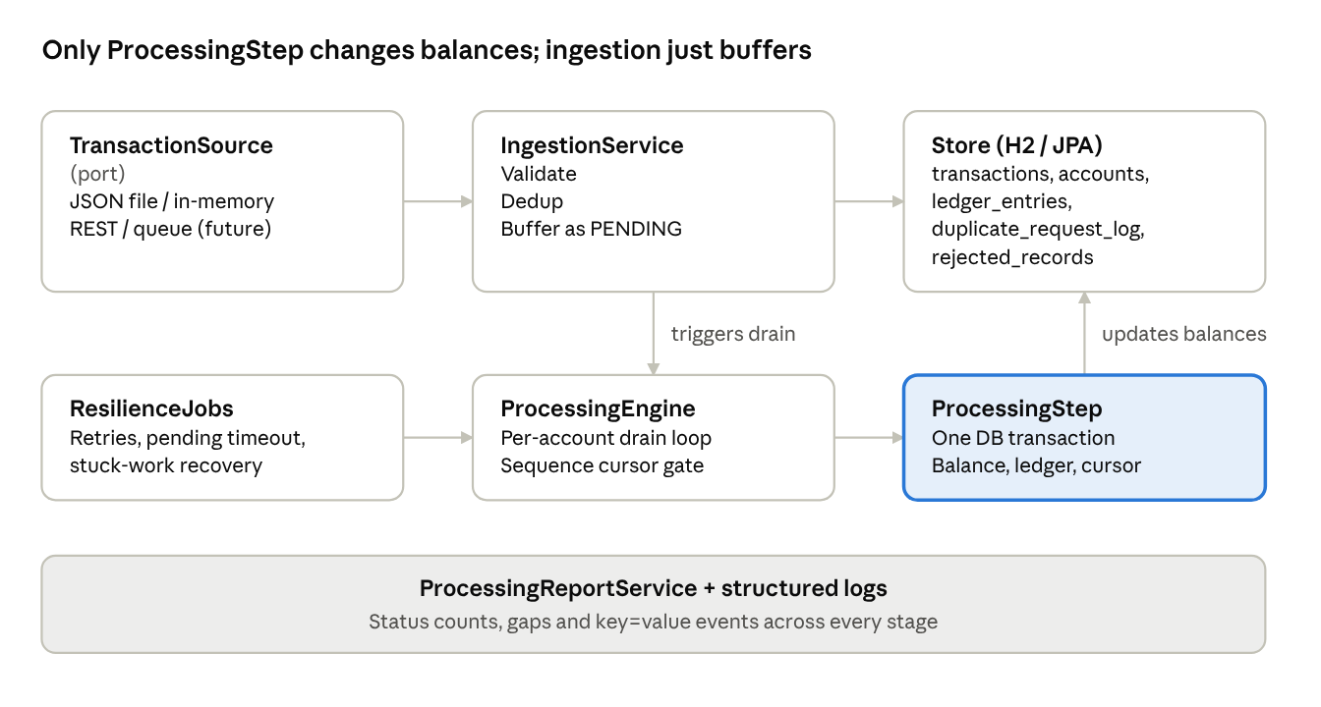
architecture · 7 components
Ingestion only buffers records; the engine drains each account through ProcessingStep, the single place balances change, and resilience jobs feed retries back in.
- Domain and rules (SequenceGate, RetryPolicy, validator) are plain Java with no framework dependency, so they are unit-testable in isolation.
- Time is injected through a Clock, so retry delays and timeouts are tested without sleeping.
- Configuration (retry delay 30s, max attempts, pending timeout, lease timeout) lives in @ConfigurationProperties.
- Scope: only CREDIT and DEBIT; sequence numbers are per account; each account is assumed to be single-currency.

Database design
The in-memory H2 schema is created on startup and dropped on shutdown. Tables are related only by IDs, and unique keys on transaction_id and on each account's sequence slot are what keep processing idempotent.
Foreign keys are deliberately not declared: a transaction that fails validation can carry an account ID that never gets an accounts row, and a strict foreign key would reject it. The trade-off is that the database does not block orphaned rows, so production should add foreign keys where references are guaranteed, such as ledger entries.
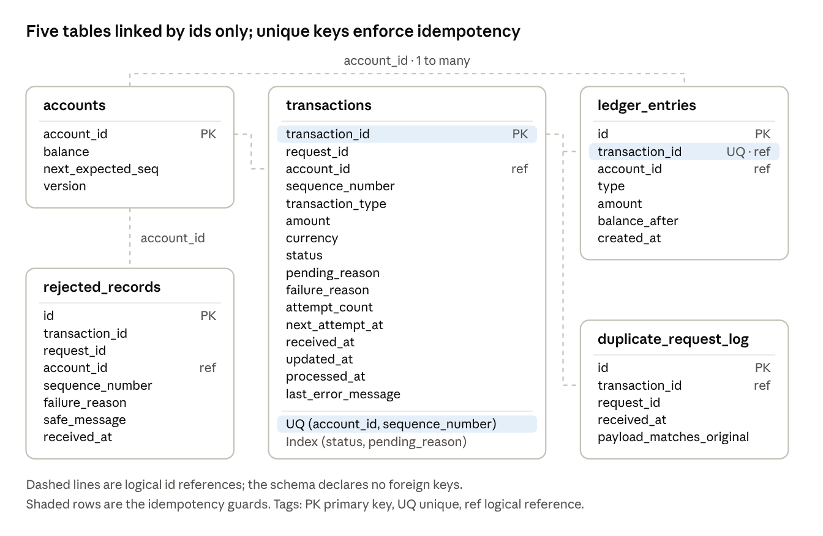
database design · 5 tables

2. Idempotency design
The idempotency key is the business transactionId, not the transport-level requestId, because the same business event can be re-sent under a new request id.
- The transactions table has a primary key on transactionId, so the database itself prevents a second row, even under concurrent arrival.
- The ledger_entries table has a unique constraint on transactionId as a last-line guard: a balance can only be changed once per transaction.
- Applying a transaction is one atomic DB transaction: lock the account row, update the balance, write the ledger entry, mark PROCESSED, advance the sequence cursor. If anything fails, everything rolls back, so a retry always starts from a clean state and cannot double-apply.
- State is persisted (status, attempt count, next-attempt time), so idempotency survives restarts and does not depend on in-memory caches.

3. Duplicate detection logic
- On arrival, look up transactionId. If a row exists, the new arrival is a DUPLICATE.
- Per the agreed rule, a duplicate is a duplicate even if its payload differs. The first arrival wins and the original record is never modified.
- The duplicate is written to duplicate_request_log (its requestId, arrival time, and a flag saying whether the payload matched the original), so changed-payload duplicates stay visible to operators.
- This works regardless of the original's state: processed, buffered awaiting sequence, awaiting retry, or failed.
- A concurrent race on the same id is resolved by the primary key. The loser catches the constraint violation and is treated as a duplicate.

4. Out-of-order handling strategy
Strategy: sequence-based buffering with a per-account cursor. Because the balance must never go negative, execution order changes outcomes (a DEBIT of 40 fails before a CREDIT of 100 but succeeds after it). So events cannot simply be applied as they arrive; only strict sequencing gives a deterministic final balance.
- Each account holds nextExpectedSeq, starting at 1.
- A transaction executes only when its sequence equals the cursor. Early arrivals are stored as PENDING with reason AWAITING_SEQUENCE.
- After each success, a drain loop pulls the next buffered sequence, so one late arrival can release a whole chain.
- A terminal outcome (PROCESSED or FAILED) advances the cursor, so a failed transaction never blocks the account. A record awaiting retry does not advance it, which keeps later operations from jumping ahead of a dependency.
- Sequences that cannot own a slot (stale, or conflicting with an existing holder) are rejected and recorded.
- Gaps are never auto-skipped. After the pending timeout (default 5 minutes), buffered records become FAILED with SEQUENCE_TIMEOUT but keep their slot. If the missing sequence later arrives, the cursor steps over them. Silently skipping a missing debit or credit would be worse than stalling, so gaps are reported instead.
- Accounts are independent, so different accounts can be processed in parallel while each account stays serial.

5. Retry and failure handling
Kind | Examples | Outcome
Permanent | Validation error, insufficient funds, stale or conflicting sequence | FAILED with a reason, never retried
Transient | Internal or infrastructure error | Retried after a configurable delay
- On a transient error the processing transaction rolls back, then a separate transaction records the attempt: status PENDING/AWAITING_RETRY with nextAttemptAt = now + delay (default 30s).
- A scheduler polls for due retries, so the schedule is stored in the database and survives restarts.
- After the configured maximum attempts the record becomes FAILED with RETRIES_EXHAUSTED, the cursor advances, and later sequences continue.
- Records stuck in PROCESSING beyond a lease timeout (for example after a crash) are reclaimed and retried.
- Failures are injected for testing through a fault injector that throws after the ledger write but before commit, which proves the rollback leaves no partial state.
- Trade-off: a retry-pending record blocks later sequences on that account for at most max-attempts x delay.

6. Observability approach
- Structured logs as key=value events (for example TXN_PROCESSED, TXN_DUPLICATE, TXN_RETRY_SCHEDULED, TXN_RETRY_EXHAUSTED, TXN_TIMEOUT) with transaction id, request id, masked account and attempt number in the logging context.
- Processing report with counts by status and failure reason, retried transactions, duplicates, rejected records, and per-account balance, cursor and sequence gaps.
- Integrity check: for every account, the sum of ledger entries must equal the balance.
- Safe logging: no amounts, raw payloads, or full account ids appear in logs, and API errors never expose stack traces. A test asserts this.

7. AI-assisted development usage
Fill the bracketed parts with your real experience before submitting; this section is evaluated on honesty and judgment.
- Where AI helped: analysing the problem statement and surfacing ambiguities (global versus per-account sequences, duplicates of still-pending records), comparing ordering strategies. Github Copilot assisted in implementation.
- How I directed it: a instructions file defined the domain rules, and the work was split into four incremental steps, each ending in green tests and a commit.
- What I validated: every step had a validation checklist, including shuffled-order tests, a concurrency test, and a rollback proof that fails if atomicity is broken.
- What I corrected: money as BigDecimal instead of double, cursor advance after retry exhaustion.
- Principle: AI output is treated as a draft. I only keep code I can explain and defend.

8. Production hardening recommendations
- Persistence: replace H2 with PostgreSQL and manage the schema with Flyway migrations.
- Ingestion: consume from a durable queue such as Kafka with accountId as the partition key, which gives per-account ordering naturally; add a dead-letter queue for poison messages.
- Multi-instance safety: use SELECT ... FOR UPDATE SKIP LOCKED or a scheduler lock such as ShedLock so several instances do not run the same jobs.
- Side effects: use the transactional outbox pattern for downstream notifications so they are also exactly-once.
- Resilience: exponential backoff with jitter, circuit breakers, and a bounded retry budget.
- Operations: Micrometer metrics with alerts on sequence gaps, retry exhaustion, and queue lag; an operator API to void or skip a missing sequence with an audit trail; reprocessing tooling for failed records.
- Data lifecycle: a retention and archival policy for idempotency records and the duplicate log.
- Security: authentication and authorization on the API, input size limits, PII masking and encryption at rest, and secrets from a vault rather than configuration files.
- Testing: load and chaos tests, plus contract tests for the input source.

